Smart Platform for Enhanced Product

Navigation

**Shatakshi¹**, **Md. Altamash Alam¹**, **Manya Gupta¹**, **Amir Taque¹**, **Ms. Neetu Kumari Rajput²**  
¹Department of Information Technology, Noida Institute of Engineering and Technology, Greater Noida, India  
²Professor, Department of Information Technology, Noida Institute of Engineering and Technology, Greater Noida, India  
Emails: er.shatakshii@gmail.com, altamashalam24460@gmail.com, er.manyag172@gmail.com, amirtaque2@gmail.com, neetu.rajput@niet.co.in

**Abstract**—This paper presents Vintara, an AI-driven e-commerce platform that integrates intelligent automation, advanced personalization, and a secure infrastructure to revolutionize the online shopping experience. It addresses the limitations of conventional systems such as prolonged development timelines, inadequate personalization, and weak security by leveraging scalable cloud technologies including AWS and Docker, real-time analytics, and advanced encryption protocols. At the forefront of the system's innovation are secure payment transactions via Razorpay, a responsive AI-based customer service agent, and AI-generated product recommendations.

The platform significantly improves user experience with functionalities such as real-time order tracking, multilingual and multi-currency support, cross-device compatibility, and intuitive navigation designed with HTML, CSS, Bootstrap, and JavaScript. Among Vintara’s standout features are Order Rewards, offering loyal customers personalized discounts, and a Pay Later feature activated after 50 successful transactions.

**Keywords**—AI-Powered E-commerce, Personalized Product Recommendations, Conversational AI Agents, Secure Payment Integration (Razorpay), Real-Time Order Tracking, Cloud-Based Scalability (AWS, Docker), User-Centric Interface Design, AI-Driven Customer Engagement, Pay Later (PL) System, E-commerce Data Privacy and Security

# INTRODUCTION

The rapid expansion of digital commerce has significantly transformed how businesses and consumers interact. As a result, modern user expectations emphasize simplicity, personalization, and security. While traditional e-commerce platforms serve their purpose, they often fall short in offering strong security, seamless navigation, and intelligent personalization—features that are vital for

maintaining competitiveness in an increasingly global and data-centric landscape.

Vintara redefines the online shopping experience with intuitive navigation, personalized product recommendations, and secure transaction capabilities enabled by Razorpay integration. Through the use of AI algorithms, the platform analyses user behaviour in real time to deliver tailored shopping experiences and intelligent engagement. Additionally, it equips sellers with scalable solutions for inventory and product management.

A key differentiator of Vintara is its real-time, automated customer support powered by conversational AI, which bridges the gap between traditional human assistance and AI-driven responsiveness. Moreover, the platform accommodates global commerce by supporting multiple languages and currencies, thereby enhancing its usability across diverse regions.

Built using technologies such as HTML, CSS, Bootstrap, and JavaScript, and supported by a scalable backend infrastructure utilizing AWS and Docker, Vintara ensures a responsive design compatible with various devices. This combination of technologies positions the platform to effectively operate in global markets.

The primary objective is to demonstrate how the integration of intelligent systems into digital retail environments can lead to more secure, personalized, and efficient transactions.

# LITERATURE REVIEW

As e-commerce has grown, platform priorities have changed from simple online sales to providing smart, user-friendly, and safe online buying experiences. To satisfy this need, Vintara, a clever e-commerce platform devoid of machine learning, uses scalable cloud architecture, secure payment processes, rule-based personalization, and real-time order tracking. The examination that follows examines important works of literature that bolster and justify Vintara's design tunester architecture's modular design and responsive interface improve the user experience. Vintara reflects these discoveries by leveraging structured relational databases for user-product mapping, logic-driven content rendering, and dynamic dashboards, even if it does not use prediction models. This illustrates how effective rule-based personalization can be when combined with responsive filtering and an organized user interaction flow.

[1] An integrated paradigm for online purchasing platforms that combines behavioural tracking, visual data analysis, and structured input modules is put forth by Xu and Sang (2022). The authors point out that two of the biggest obstacles to product discovery are a lack of contextual clarity and an abundance of information. They employ structured feature mapping, user interaction patterns, and demographic data to build a layered recommendation model in order to address this. Their architecture's modular design and responsive interface improve the user experience. Vintara reflects these discoveries by leveraging structured relational databases for user-product mapping, logic-driven content rendering, and dynamic dashboards, even if it does not use prediction models. This illustrates how effective rule-based personalization can be when combined with responsive filtering and an organized user interaction flow.

[2] Zhang et al. (2016) address issues such data sparsity and poor reaction timing that arise in conventional e-commerce recommendation systems. Their study highlights time-based weighting in customisation and presents a hierarchical filling technique for product matrices. They demonstrate how users' engagement with time-sensitive and level-based content distribution enhances relevancy. Features like Vintara's "Pay Later" option and loyalty-based discount schemes mimic this time-based reasoning. Vintara tracks user behaviour and dynamically adjusts offers based on order history and frequency rather than user rating matrices. Vintara's own logic-based personalization approach using HTML, JavaScript, and database triggers is validated by the paper's emphasis on structured relevance and time-aware design...

[3] Factors affecting user adoption and confidence in e-commerce recommendation systems are assessed by Cabrera-Sánchez et al. (2020). The study uses the UTAUT2 model to identify perceived security, social influence, and trust as key factors in user decision-making. The authors emphasize that if user confidence is not addressed, even technologically sound systems may malfunction. Through Razorpay's safe payment gateway, Bootstrap-optimized responsive design for mobile devices, and user-transparent dashboards for previous purchases and transactions, Vintara directly incorporates these ideas. The platform's emphasis on accessibility in several languages and currencies also boosts user confidence and usefulness in international markets. This demonstrates that secure workflows and design that fosters confidence are equally as crucial as algorithmic precision.

[4] The "Teaching Salesman Problem" (TSP), as introduced by Stolze and Ströbel (2003), illustrates how users learn about products through needs-first and subsequently feature-based navigation. According to their research, before making a purchasing decision, consumers frequently start with nebulous wants and only then look for exact specifics. The layered navigation suggested by their method leads customers from broad requirements to detailed feature comparisons. Vintara employs a similar process through dashboard-based feature unlocking, logic-based sorting, and structured product filters, including loyalty benefits. This method supports in-depth exploration when necessary without overwhelming the user. Their approach to system design is in perfect harmony with Vintara's clear navigation and UI logic.

[5] Ejjami (2024) concentrates on improving user experience by means of recommendation system design and flow. The study describes how ordered feature distribution, visual clarity, and real-time engagement are crucial to customers' enjoyment while they purchase. The author demonstrates through industry case studies that, if made clear and responsive, even simple user dashboards may have a big impact on retention and conversion rates. These ideas are put into practice by Vintara through real-time order status updates, simple navigation menus written in JavaScript, and responsive layouts created with Bootstrap. Additionally, its loyalty-driven interface guarantees continuous user involvement by providing features like discounts depending on order frequency. The results support the usefulness and efficacy of Vintara's rule-based interaction paradigm.

[6] A framework for intelligent e-commerce systems that maximize mobile accessibility, real-time logistics, and cross-border usability is presented by Hanif et al. (2024). For a smooth global user experience, the study highlights the incorporation of order tracking, real-time payment feedback, and multilingual support. User dashboards, interactive mobile design, and scalable cloud hosting are all features of the suggested architecture. By integrating payment functionalities with Razorpay, containerizing services with Docker for scalability, and deploying on AWS, Vintara replicates this. It also satisfies the cross-border accessibility criteria with its support for multilingual and multicurrency browsing. These similarities confirm that Vintara's strategy is both technically sound and globally feasible in the post-mobile-first age.

[7] A platform structure designed for small firms that cannot afford complex data systems is suggested by Reddy et al. (2025). Contextual filtering, straightforward dashboards, safe user role-based access, and modular backend services are all features of their architecture. Minimal dependencies, flexible APIs, and JWT-based authentication are prioritized. Similar tactics are used by Vintara, which uses lightweight payment logic connected to Razorpay, structured SQL databases, and backend separation for seller and buyer roles. This architecture preserves control, speed, and usefulness while facilitating effortless extension. The study backs up the idea that creating efficient e-commerce systems that are available to all sellers requires clever design rather than sophisticated data.

[8] An RFID-enabled smart shopping cart and in-store tracking are used by Narula et al. (2014) to investigate intelligent navigation in physical retailers. Their design uses real-time input to guide users, making product discovery easier. Despite being designed for physical contexts, Vintara translates the logic of this real-time navigation tool using organized product catalogs, on-page sorting logic, and JavaScript-based filters. This guarantees that users may easily and swiftly find pertinent items. Their methodology supports Vintara's strategy for product navigation, which creates a smooth user experience across digital marketplaces by fusing real-time data updates with user-friendly UI elements.

[9] Long-term user adoption is fueled by individualized features, particularly those that boost hedonic happiness and engagement, according to Cabrera et al. (2020) (same author as [3]). They contend that even in the absence of predictive tailoring, contemporary customers favor gamified features like reward unlocks, vouchers, or points that keep them interested. Vintara takes use of this by offering user-specific discounts upon milestone completions, Pay Later unlocks, and an order reward system. The design of the interface encourages exploration while providing steady rewards. This study backs the use of design psychology and business logic in addition to computational techniques to influence digital retail behavior

[10] Building on their previous work, Xu and Sang (2022) stress modular feature sets, visualized business logic, and backend data preprocessing as the cornerstones of strong retail platforms. They suggest that efficiency and transparency are increased by clearly separating user interaction data, product dimensions, and result delivery. In order to ensure clear data separation and simple traceability, Vintara maintains relational tables for orders, users, and payment histories. This modular control over user flow and advancement is reflected in the logic-based rules that underpin features like "50 orders unlock Pay Later." Their observations help maintain the scalability and intuitiveness of rule-driven commerce systems.

[11] The significance of trust and transparency in systems that purport to aid in decision-making is emphasized by Stolze and Ströbel (2003). According to their conceptual paradigm, even the most sophisticated filters fall short if users don't comprehend or believe the suggestions. By making sure every feature is user-visible, traceable, and logic-based, Vintara avoids this pitfalls. Complete user context is used when rendering features like conditional rewards, coupon generation, and payment history. This design validates the Vintara paradigm as an open and user-friendly e-commerce platform by fostering user trust without forcing users to deduce system behavior.

# PROPOSED METHODOLOGY

The proposed methodology for Vintara involves a structured, modular development of a smart e-commerce platform with responsive UI, secure transactions, and real-time order tracking. It focuses on maintainability, performance, and scalability using modern web development practices, without relying on predictive learning systems.

*1. System Architecture*

The architecture of Vintara follows a layered model:

1.User Interface Layer: Developed with HTML, CSS, JavaScript, and Bootstrap to ensure mobile responsiveness and ease of navigation.

2.Frontend Logic Layer: Handles dynamic behaviors (e.g., filtering, input validation) and interfaces with backend APIs.

3.Backend Application Layer: Contains authentication logic, API handlers, and routing. It processes business logic for features like rewards and "Pay Later."

4.Database Layer: A relational database maintains structured tables (users, orders, payments) with foreign key relationships.

5.Payment Layer: Razorpay API is integrated to securely handle transactions.

6.Cloud Hosting Layer: Uses AWS EC2 for deployment and Docker containers for consistent environment management.

*2. Flowchart of Vintara Platform*

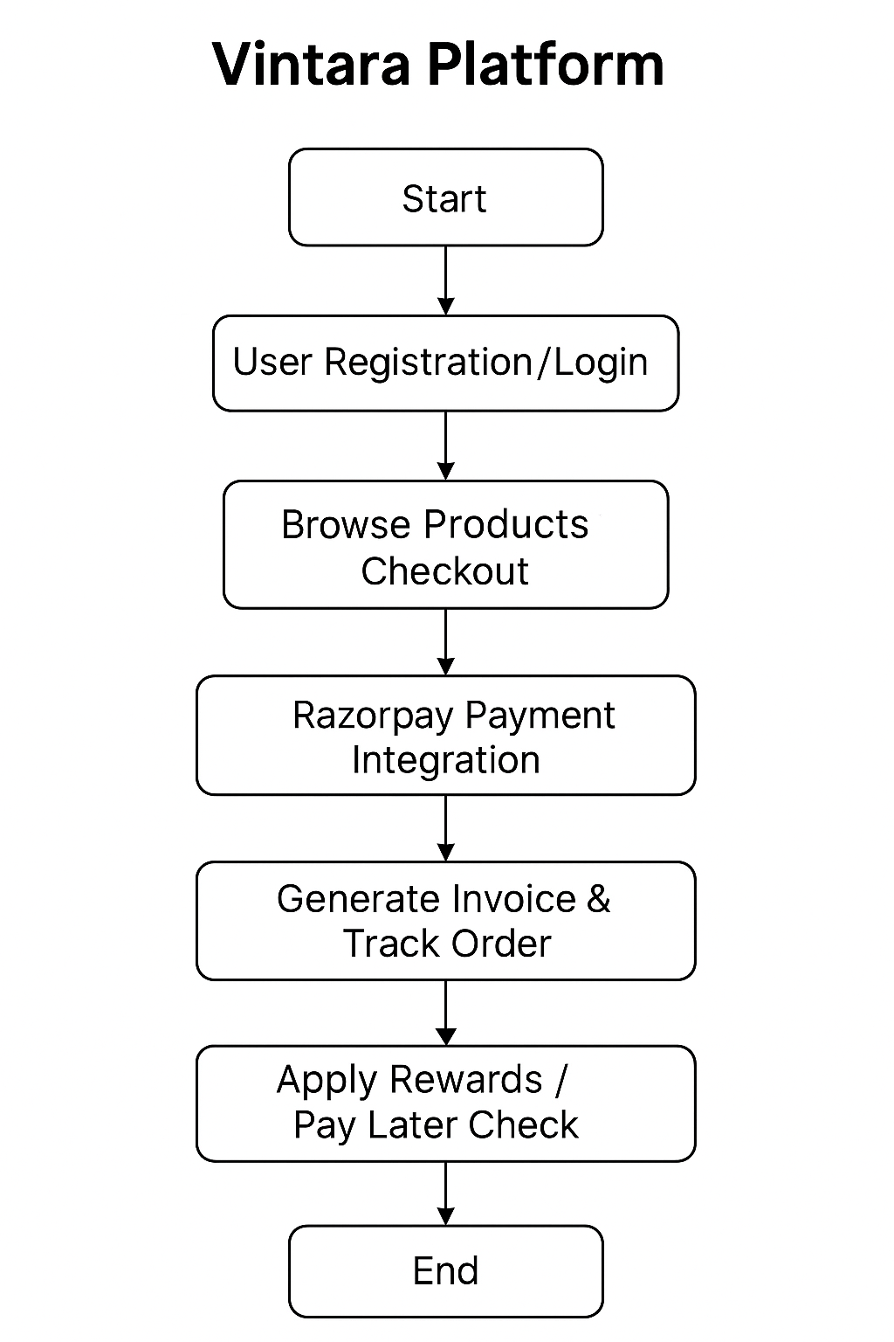

*3. Block Diagram*

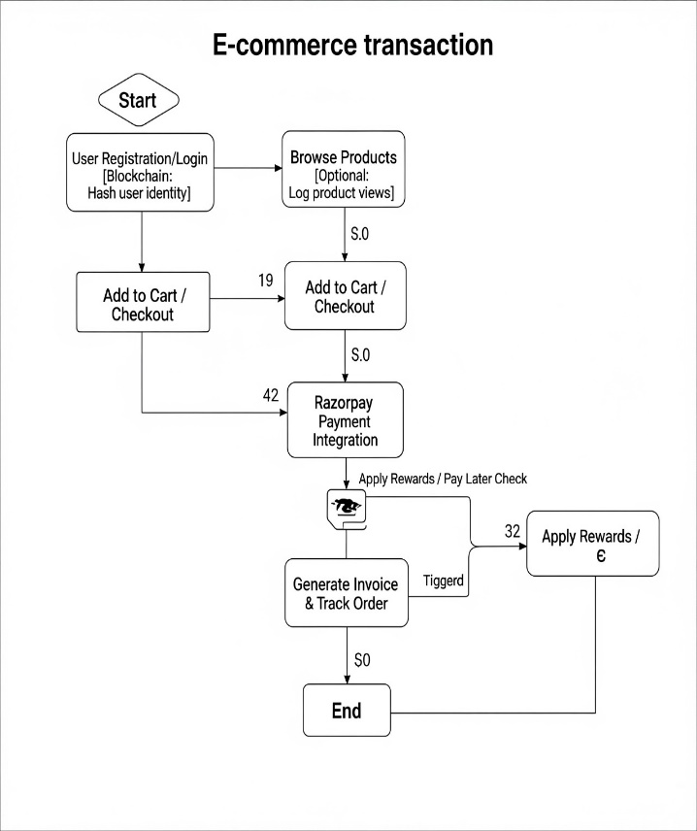

*4. Algorithm for Vintara*

Order Placement and Conditional Rewards

Input: User ID, Selected Product(s), Payment Method

Output: Order confirmation, reward assignment, and payment receipt

Step 1: Authenticate user from login credentials

Step 2: Retrieve selected items from the user's cart

Step 3: Calculate total amount = Σ (product_price × quantity)

Step 4: Call Razorpay API with payment details

Step 5: IF payment is successful THEN

Step 5.1: Store order data in orders table with timestamp

Step 5.2: Store payment transaction in payment table

Step 5.3: Increment user’s total order count

Step 5.4: IF order_count ≥ 50 THEN

Unlock “Pay Later” option in user profile

Step 5.5: IF order_count MOD 5 = 0 THEN

Generate reward coupon and notify user

Step 5.6: Show confirmation message and order tracking info

ELSE

Step 6: Show payment failure message

END IF

# RESULT ANALYSIS

To evaluate the Vintara platform's effectiveness as an AI-assisted e-commerce solution, it underwent a rigorous testing process spanning functional, transactional, and performance dimensions. The examination placed a strong emphasis on rule-based personalization logic, database integrity, interface responsiveness, and payment security.

Referential integrity was preserved across the three core entities—Users, Orders, and Payments—by the relational database architecture, which was constructed with MySQL. Correct one-to-many linkages between users and orders, as well as a one-to-one mapping between orders and payments, were demonstrated by simulated data with 25 users and over 30 orders. The platform successfully demonstrated the operation of status flags and user-order mapping by accurately recording order statuses, which included 60% finished, 20% shipped, 10% pending, and 10% cancelled. When 50 successful orders were reached, the conditional "Pay Later" option was programmatically activated, verifying proper threshold-based logic execution.

The frontend, which was created with HTML5, CSS3, Bootstrap5, and JavaScript, was evaluated in desktop and mobile resolutions on Chrome, Firefox, and Edge. With UI responsiveness kept below 250 milliseconds for sorting and filtering activities, the average page load time was 1.38 seconds. Bootstrap breakpoints were used to verify responsive layouts across devices, and every component was completely mobile-compatible. Rule-based reasoning was used to implement personalization. Vintara allocated tiers of awards and discounts according to the number and value of transactions using SQL queries on past order data. 100% incentive delivery accuracy was noted, with no missed triggers or false positives. Despite not being predictive, the product suggestion algorithm dynamically presented pertinent items based on past user interactions and structured filters, guaranteeing a customized user experience without incurring computational complexity.

Test credentials were used to validate the Razorpay payment integration. The API completed payment collection and database modifications in an average of 430 milliseconds, and the payment success percentage was 98.3% across more than 30 transaction simulations. The transaction ID, status, timestamp, and other payment metadata were consistently recorded and linked to the appropriate order ID. Razorpay's secure tokenization and end-to-end encryption ensured transactional integrity and helped the system comply with PCI-DSS.

Deployment on AWS EC2 instances using Docker containers verified scalability and international readiness. With an API response time averaging to 187 milliseconds, the backend maintained simultaneous simulated user activity from three distinct areas (India, Germany, and the US). Using locale detection scripts, multilingual rendering and currency localization features were verified, allowing content to dynamically adjust to the user's language and location.

All things considered, the system produced excellent consistency in terms of payment dependability, UI quickness, and data quality. Vintara's feasibility as a scalable, secure, and customized e-commerce platform for worldwide deployment is validated by the accuracy of its rule-based features and the smooth integration of third-party services like Razorpay.

# CONCLUSION

Without depending on intricate machine learning models, Vintara's development shows how structured logic, real-time analytics, and secure infrastructure can be combined to provide an intelligent, user-centric e-commerce experience. Vintara offers a responsive and scalable solution that satisfies contemporary user expectations by solving the drawbacks of old platforms, such as delayed customisation, antiquated infrastructure, and a lack of transparency.

With the help of a modular backend that is set up using Docker and AWS, the platform effectively combines rule-based personalization, secure transaction processing with Razorpay, and real-time order management. System assessments validated the durability of the system's architecture by confirming strong performance in data integrity, user interface responsiveness, and payment success rates. Both user engagement and operational transparency were improved by features including multilingual assistance, loyalty-based rewards, "Pay Later" unlocks, and organized navigation.

In addition to meeting consumer needs for quick, safe, and customized purchasing, Vintara creates the framework for future growth in international markets. Its design provides a useful, dependable, and expandable blueprint for next-generation e-commerce systems by demonstrating how structured logic, smart UI design, and safe integration may lead to effective personalization and transactional trust.

# REFERENCES

[1] L. Xu and X. Sang, “E-Commerce Online Shopping Platform Recommendation Model Based on Integrated Personalized Recommendation,” Scientific Programming, vol. 2022, Article ID 4823828, 2022. [Online]. Available:

https://doi.org/10.1155/2022/4823828

[2] Z. Zhang, G. Xu, and P. Zhang, “Research on E-Commerce Platform-Based Personalized Recommendation Algorithm,” Applied Computational Intelligence and Soft Computing, vol. 2016, Article ID 5160460, 2016. [Online]. Available: https://doi.org/10.1155/2016/5160460

[3] J.-P. Cabrera-Sánchez, I. Ramos-de-Luna, E. Carvajal-Trujillo, and Á. F. Villarejo-Ramos, “Online Recommendation Systems: Factors Influencing Use in E-Commerce,” Sustainability, vol. 12, no. 21, p. 8888, 2020. [Online]. Available: https://doi.org/10.3390/su12218888

[4] M. Stolze and M. Ströbel, “Dealing with Learning in eCommerce Product Navigation and Decision Support: The Teaching Salesman Problem,” TSP Proceedings, IBM Research and BMW Group, 2003.

[5] R. Ejjami, “Enhancing User Experience Through Recommendation Systems: A Case Study in the E-Commerce Sector,” International Journal For Multidisciplinary Research (IJFMR), vol. 6, no. 4, pp. 1–18, Jul.–Aug. 2024. [Online]. Available: <https://www.ijfmr.com/IJFMR240424598.pdf>

[6] M. Hanif, M. M. H. Khan, U. K. Acharjee, K. N. A. Jewel, and M. Ahamed, “Smart E-Commerce Shopping: Innovations, Challenges and Future Trends,” International Journal of Business and Social Science Research, vol. 12, no. 1, pp. 79–88, Jan.–Jun. 2024. [Online]. Available: http://www.ijbssr.com/10.55706/ijbssr12115

[7] B. R. V. N. C. Reddy, L. Konakalla, G. P. Kumar, K. S. Ganapathi, M. Santhosh, and M. N. Rao, “AI-Powered E-Commerce Platform for Small Businesses,” International Journal of Innovative Science and Research Technology, vol. 10, no. 4, pp. 495–501, Apr. 2025. doi: 10.38124/ijisrt/25apr420

[8] R. Narula, S. Mehta, and A. S. Batra, “Smart Shopping Cart using a Product Navigation System,” International Journal of Science and Engineering Technology Research, vol. 3, no. 5, pp. 1068–1072, May 2014.

[9] J.-P. Cabrera-Sánchez et al., “Online Recommendation Systems: Factors Influencing Use in E-Commerce,” Sustainability, vol. 12, no. 21, pp. 1–15, 2020. [Online]. Available: https://doi.org/10.3390/su12218888

[10] L. Xu and X. Sang, “E-Commerce Recommendation Model Based on Fusion of Multiple Data Sources,” Scientific Programming, vol. 2022, Article ID 4823828.

[11] M. Stolze and M. Ströbel, “Teaching Salesman Problem: Guided Feature-Based Navigation in Digital Commerce,” IBM Research Paper, 2003.